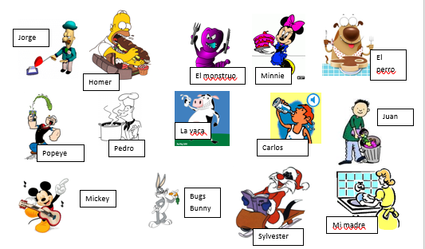
These pictures will be on your quiz. I will ask 7 questions of who (¿Quién? or ¿Quiénes?) is/are doing different things, and you will have to answer with a full sentence with the DOP (lo, la, los, or las). This is similar to the DOP worksheet with pictures called “Tarea de DOP”, but this one will use more verbs than just comer. Each answer will be worth 2 points as you need to write out the answer with the correct character, DOP, and verb.
Write our class example of a question and answer here:
____________________________________________________________
____________________________________________________________
Then make up your own two questions and answers below. Underline the direct object in your question and underline your direct object pronoun in the answer.
1. ____________________________________________________
_______________________________________________________
2. ____________________________________________________
_______________________________________________________
TURN THE PAGE FOR MORE
Monday night’s homework will be a Quizlet with questions and answers that fellow students make up. The more questions we have, the better practice for the Quizlet.
Additionally, there will be a section on the quiz for you to fill in the blank with the correct reflexive word: me, te, le, nos, or les. You need to know which one to use with tocar or parecer. Hint: see the personal a. I will list these words in alphabetical order on the test, and you will put the correct word on the blank.
YOU WILL NEED TO TRANSLATE ONE OR MORE OF THE SENTENCES FOR AN ACTUAL TEST POINT OR POINTS. Review the old Quizlets on parecer, tocar, and encantar including the translations one and the test you got back.
Another section will require you to figure out the correct form of ser or estar for the sentence. This will be matching, choose the correct letter to fill in the blank. There will be 10 conjugated verb choices for 7 questions.
YOU WILL NEED TO TRANSLATE ONE OR MORE OF THE SENTENCES FOR AN ACTUAL TEST POINT OR POINTS. Make sure you study the ser vs estar quizlets again too, including the translations!
The Quizizz that is due on Monday as well has many examples similar to what you will see on the test, except I can’t put pictures in the Quizizz. Make sure you take your time and retake it as many times as you need to master the content.
There will not be an extra credit opportunity offered after this test. But as usual, there is an opportunity to earn one extra credit point on the test itself.
We will have this quiz on Wednesday, May 8. Make sure you study so you can do a good job on it. It will be worth 30 points, and 14 of those points will be from the DOP picture part.

